**Unit 1, Lesson 3 & 4 Review Quiz**

**Multiple Choice**

*Identify the choice that best completes the statement or answers the question.*

**____ 1.** The graph below shows how long it took students to catch a ball after it was dropped.

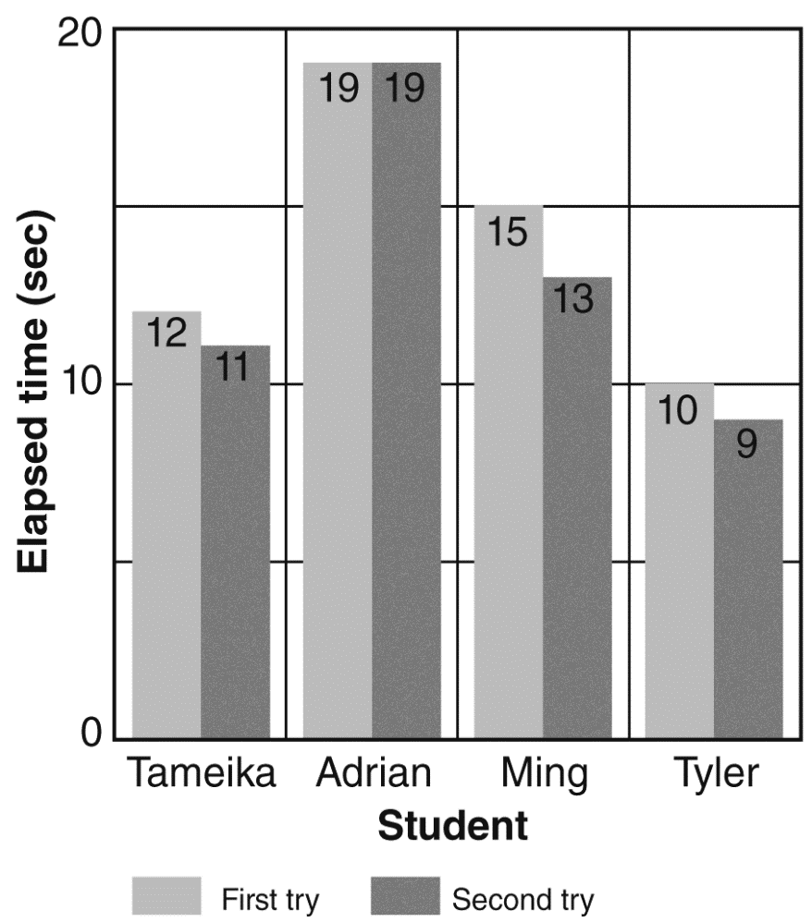

Which conclusion can you draw?

|  |  |
| --- | --- |
| **A** | On both tries, the students caught the ball in the same amount of time. |
| **B** | Students always take less time on their second try. |
| **C** | Students always take more time on their second try. |
| **D** | Students averaged one second faster on their second try. |

**____ 2.** LeShawn watches his mom rub soap on her finger to help her get a ring unstuck. He thinks that soap must reduce friction. He designs an investigation to test his theory. He pulls a weight across a board and records the force with a spring scale. He then puts soap on the board and pulls the weight again.Which of the following variables is LeShawn measuring?

|  |  |
| --- | --- |
| **A** | The force needed to pull the weight |
| **B** | the amount of weight being pulled |
| **C** | the speed with which the weight is pulled |
| **D** | the type of surface the weight is being pulled across |

**____ 3.** Sydney wonders what might make a paper plane fly farther. She makes some sample planes out of notebook paper and sandpaper of the same size. She created a design with a short wing and flew the two planes. The airplane made of notebook paper flew farther. She decides that notebook paper is better for making paper airplanes. What can Sydney do to make sure the results are valid?

|  |  |
| --- | --- |
| **A** | Use smaller sheets of paper. |
| **B** | Fly the planes longer distances. |
| **C** | Measure the weight of the sheets of paper before each flight. |
| **D** | Repeat the flights several times to make sure the results are consistent. |

**____ 4.** Why is it important to have more than one trial in an experiment?

|  |  |
| --- | --- |
| **A** | The results should differ each time. |
| **B** | One of the trials will support your hypothesis. |
| **C** | The conditions in an experiment are very different in every trial. |
| **D** | Small errors can be averaged when there are multiple trials. |

**____ 5.** Ashley observes the phases of the moon during a two-week period. She sketches and labels the phases and shares her drawings with the class. Which statement BESTdescribes Ashley’s investigation?

|  |  |
| --- | --- |
| **A** | It involves testing. |
| **B** | It involves experimentation. |
| **C** | It involves repeated observations. |
| **D** | It involves both experimentation and repeated observations. |

**____ 6.** The chart shows the steps of a scientific method.

|  |
| --- |
| **A Scientific Method** |
| • Form a hypothesis.  • Develop a plan.  • Test the hypothesis.  • Analyze results.  • Communicate results. |

Which statement is **true** of this scientific method?

|  |  |
| --- | --- |
| **A** | It should be considered a flexible guide. |
| **B** | It lists each step according to importance. |
| **C** | It is the only one that scientists use. |
| **D** | The results should not be communicated if you don’t like them. |

**____ 7.** Both experiments and repeated observations are valid methods for increasing scientific knowledge. There are many differences between the two methods. Which of the following is a similarity?

|  |  |
| --- | --- |
| **A** | Both are kinds of investigations. |
| **B** | Both are representations of objects or events. |
| **C** | Both involve observations of the natural world. |
| **D** | Both include the identification and control of variables. |

**____ 8.** Yahani conducts an experiment. Her results do not support her hypothesis. What should she do?

|  |  |
| --- | --- |
| **A** | Repeat the experiment to check for errors. |
| **B** | Change the results to support the hypothesis. |
| **C** | Discard the data because it does not agree with her hypothesis. |
| **D** | Try to make an experiment that will give her the results she wants. |

**____ 9.** Lynnen measures the distance traveled by a long-distance cyclist over time. She records the data in the table below.

|  |  |
| --- | --- |
| **Cyclist Data** | |
| **Time**  **(h)** | **Distance**  **(km)** |
| 0 | 0 |
| 1 | 33 |
| 2 | 67 |
| 3 | 99 |
| 4 | 133 |
| 5 |  |

If the cyclist continues at this pace, what distance do you predict the cyclist would travel after five hours?

|  |  |
| --- | --- |
| **A** | 140 km |
| **B** | 165 km |
| **C** | 195 km |
| **D** | 235 km |

**____ 10.** Which of the following would be **best** done using repeated observation rather than an experiment?

|  |  |
| --- | --- |
| **A** | determining the average number of times during a week in May that a group of bees visits flowers |
| **B** | determining whether a diet that includes honey every day will reduce allergies |
| **C** | determining which type of flower gives out the strongest scent |
| **D** | determining whether a bee hive is stronger than a wasp nest |

**____ 11.** Models allow scientists to test things that might be too expensive or difficult to test using the real item. Which of the following would be an investigation that could use a model?

|  |  |
| --- | --- |
| **A** | whether a new spray will repel mosquitoes |
| **B** | how many times per day a robin leaves her nest |
| **C** | how much water a cubic meter of sand can hold |
| **D** | How much weight can a new bridge support |

**____ 12.** Scientists include controls in their experiments. Why is a control important?

|  |  |
| --- | --- |
| **A** | It helps scientists share results. |
| **B** | It helps scientists form their first hypothesis. |
| **C** | It helps scientists record their repeated observations. |
| **D** | It helps scientists compare their results to a standard. |

**____ 13.** A teacher writes the following note on a student’s experimental design: “You did not identify and control variables.” Why is it important to identify and control variables?

|  |  |
| --- | --- |
| **A** | because a scientist must observe data |
| **B** | because a scientist must form a hypothesis |
| **C** | because a scientist must know which variable causes change |
| **D** | because a scientist must know which variable to use for making a model |

**____ 14.** A team of students wants to find out what time of day squirrels in a forest are most active. They observe squirrels in a forest for five days. They record the period of time of any squirrel activity they see and describe the details of that activity. This investigation is not an experiment. Why?

|  |  |
| --- | --- |
| **A** | It does not have a set research goal. |
| **B** | There are no variables being controlled. |
| **C** | There are no measurements being taken. |
| **D** | It is carried out over a long period of time. |

**____ 15.** Daniel completes an experiment testing the speed of four toy cars of different masses. After studying his data, Daniel thinks that the result for one of the cars is unusual. Daniel decides that he wants to check his experiment to see if his results are reliable. What would be **best** for Daniel to do?

|  |  |
| --- | --- |
| **A** | Ignore the incorrect data and use his results. |
| **B** | Repeat the experiment using different toy cars. |
| **C** | Repeat the experiment using the same conditions. |
| **D** | Start a different experiment testing the same thing. |

**Unit 1, Lesson 3 & 4 Review Quiz**

**Answer Section**

**MULTIPLE CHOICE**

**1.** ANS: D

A is incorrect because some students caught the ball more quickly on their second attempt.

B is incorrect because one student had the same reaction time in both the first and second ball drop.

C is incorrect because the students’ reaction times always stayed the same or improved.

D is correct because one student’s reaction time stayed the same, and the other students improved their reaction time on the second drop.

**2.** ANS: A

A is correct because the force needed to pull the weight would give information about the amount of friction being exerted in each trial.

B is incorrect because the weight is the same in both trials.

C is incorrect because the speed is not being measured.

D is incorrect because the type of surface is not being changed or measured.

**3.** ANS: D

A is incorrect because Kylie is using papers that are the same size. A smaller sheet of paper would simply make a smaller plane.

B is incorrect because she does not control how far the planes fly. The experiment will help her find what makes planes fly farther.

C is incorrect because knowing the weight of the paper will not change how the planes fly.

D is correct because repeated trials help ensure that the results are accurate and that mistakes were not made in procedures or data collection.

**4.** ANS: D

A is incorrect because the results should be very much the same each time unless there is a significant error.

B is incorrect because the average of all the trials will support or will not support the hypothesis.

C is incorrect because the conditions in every trial should be as much the same as the other trials as possible.

D is correct. Different trials can give similar, if not exact, results. When a trial differs widely, then the procedure can be examined for errors. If only one trial was done, we wouldn’t know if it was a trial that contained an error.

**5.** ANS: C

A is incorrect because Sandy does not make a model; rather, she draws her observations.

B is incorrect because the investigation does not involve experimentation.

C is correct because Sandy watches the moon and records her observations.

D is incorrect because there is no experiment.

**6.** ANS: A

A is correct because the scientific method is a general guide that may be modified as necessary.

B is incorrect because the steps of the scientific method are not listed according to importance.

C is incorrect because scientists follow different procedures, which are often guided by the investigation itself.

D is incorrect because information is important even if you don’t like what you find out.

**7.** ANS: A

A is correct because both experiments and repeated observations are methods for investigation.

B is incorrect because models, not experiments or repeated observations, are representations of objects or events.

C is incorrect because repeated observations, not experiments, involve observations of the natural world.

D is incorrect because controlled experiments, not repeated observations, identify and control variables.

**8.** ANS: A

A is correct because she should make sure that the information she obtained was correct.

B is incorrect because the results are what they are; she should not change them to support her hypothesis.

C is incorrect because the results are what she obtained; they can help her learn about her idea and give her ideas on how she might change her hypothesis.

D is incorrect because she should attempt to obtain accurate results, not develop an experiment to get the results she wants.

**9.** ANS: B

A is incorrect because the cyclist travels at a rate of about 33 km/h, and this only adds 7 km to the distance cycled in four hours.

B is correct because the cyclist travels at a rate of about 33 km/h, and this adds 32 km to the distance cycled in four hours.

C is incorrect because the cyclist travels at a rate of about 33 km/h, and this adds 62 km to the distance cycled in four hours, which is too great of an increase.

D is incorrect because the cyclist travels at a rate of about 33 km/h, and this adds 102 km to the distance cycled in four hours, which is too great of an increase.

**10.** ANS: A

A is correct because this would need to be done through careful observation and analysis of data.

B is incorrect because this would need an experiment with controls and conditions.

C is incorrect because this would need a determination of what constitutes the strongest scent and instruments to determine which flower exhibits it.

D is incorrect because this would need to have criteria and tests to determine which was strongest.

**11.** ANS: D

A is incorrect because this could be done with the real spray and real mosquitoes.

B is incorrect because this could be done through observation.

C is incorrect because the amount of water a cubic meter of sand can hold can be measured in the lab.

D is correct because we would want to know the maximum load a bridge can hold before it is put into service.

**12.** ANS: D

A is incorrect because publications, not controls, help scientists share results.

B is incorrect because scientists determine their hypothesis before conducting the experiment.

C is incorrect because scientists use the controls for comparing the results, not for recording them.

D is correct because a control gives scientists something to compare their results to, for example, determining whether medicine A is better at reducing flu symptoms than medicine B, where medicine B is the control.

**13.** ANS: C

A is incorrect because the failure to identify and control variables does not affect a scientist’s ability to observe data.

B is incorrect because the failure to identify and control variables does not affect a scientist’s ability to form a hypothesis.

C is correct because a scientist must control variables to know which variable causes change.

D is incorrect because the variable is important for seeing what change occurred. Making a model is often used for testing variables.

**14.** ANS: B

A is incorrect because finding what time of day the squirrels are most active is the goal.

B is correct because an experiment has controls and the students are not controlling anything.

C is incorrect because recording the period of highest squirrel activity is a measurement of time.

D is incorrect because the length of an investigation does not distinguish between observations and experiments.

**15.** ANS: C

A is incorrect because ignoring the incorrect data would not help Ray determine whether or not his results were reliable; it would lead others to think the data was not reliable.

B is incorrect because changing the toys cars would make it a different experiment and interfere with determining whether or not the data from the initial experiment was reliable.

C is correct because repeating an experiment and comparing results is the best way to be sure the data is reliable.

D is incorrect because a completely different experiment would have different results; there would be no way to tell if the results from the first experiment were reliable or not.